**Phishing Email**

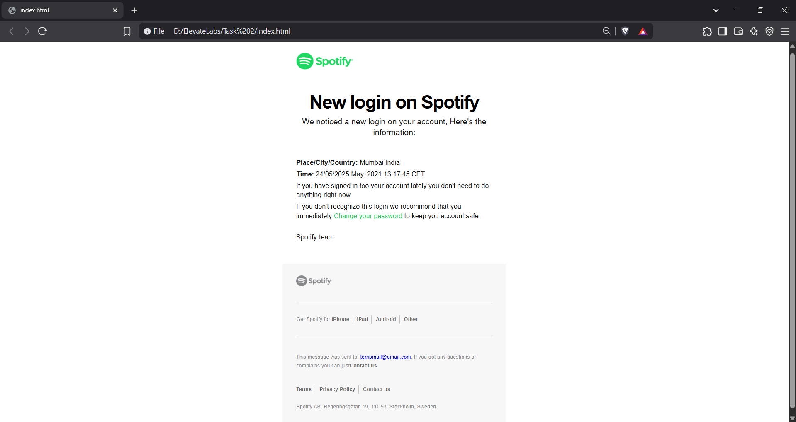

**Original Email**

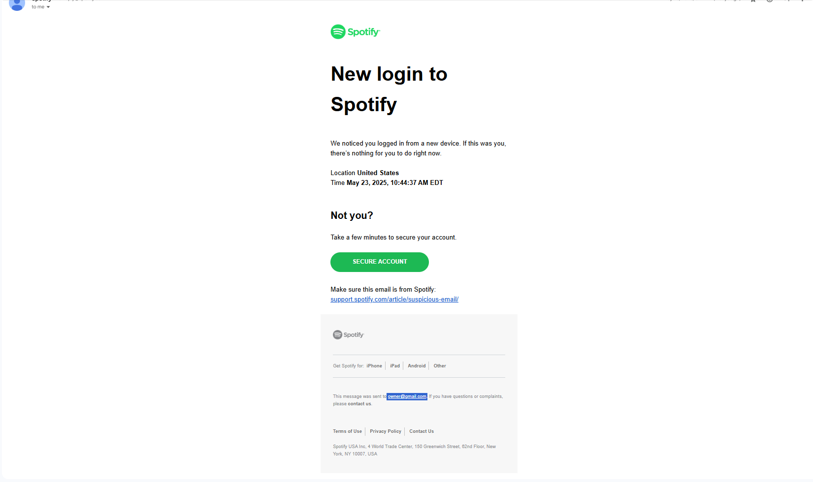

**Email Headers:**

|  |  |
| --- | --- |
| **Header Name** | **Header Value** |
| **From** | **Spotify Inc.<spotify@sci-borg.co.uk, rajibdeb@revision.sci-borg.co.uk>** |
| **To** | **<tempmail@gmail.com>** |
| **Reply-To** | **<spotify@sci-borg.co.uk>** |
| **Date** | **Wed, 09 Apr 2025 02:44:51 UTC (14 minutes ago)** |
| **IP** | **159.65.19.128 none** |
| **Subject** | **New login to Spotify** |

**Sender’s Emails:**

* [**spotify@sci-borg.co.uk**](mailto:spotify@sci-borg.co.uk)
* [**rajibdeb@revision.sci-borg.co.uk**](mailto:rajibdeb@revision.sci-borg.co.uk)

**Urgent or Threatening language in the email body**

* “New login on Spotify”
* “We noticed a new login on your account…”
* “If you don't recognize this login we recommend that you immediately Change your password…”

**Mismatched URL:**

[www.phishspotify.com](http://www.phishspotify.com) is used instead of [www.spotify.com](http://www.spotify.com)

**Phishing Analysis of Email**

1. Phishing Link:

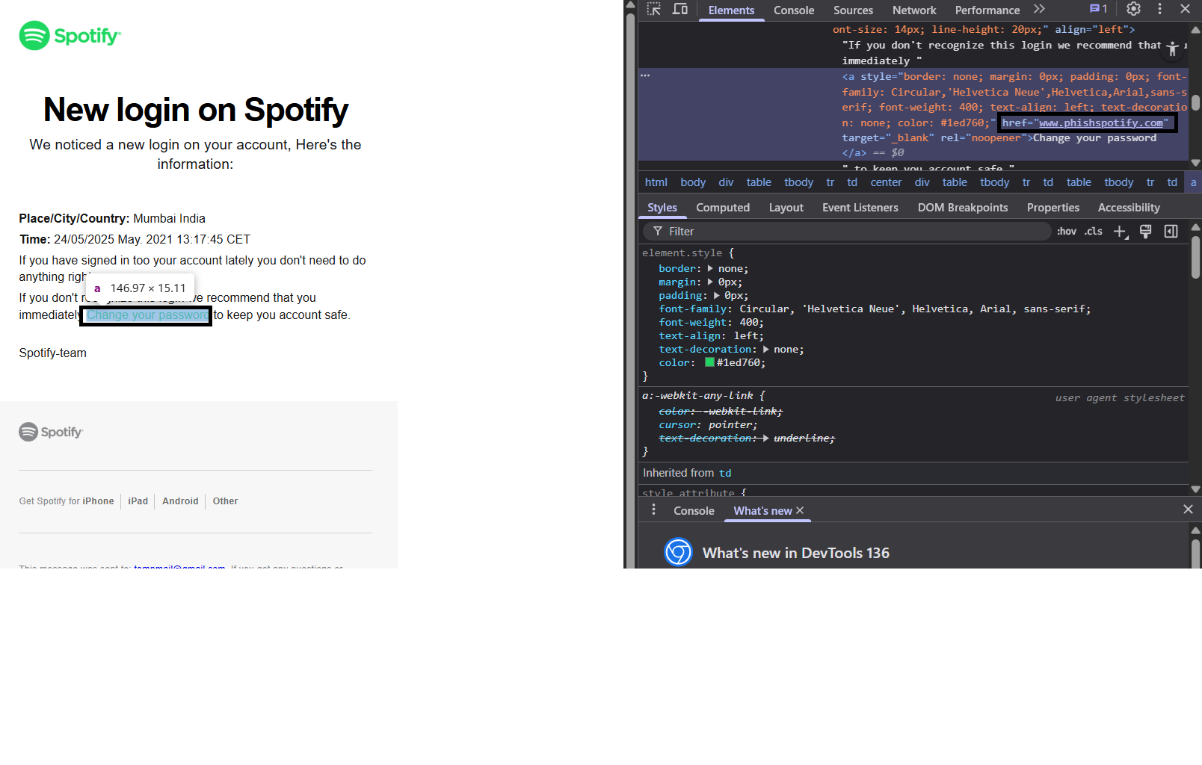

1. Grammar and Typos:

|  |  |
| --- | --- |
| Sentence | Issue |
| "If you have signed in too your account lately..." | Should be "to your account". |
| "keep you account safe." | Should be "your account". |

1. Improper Address:

Original Address in Email:

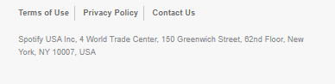

Address in Phishing Email

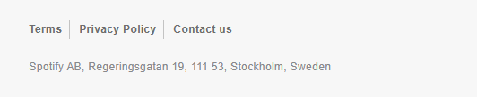

1. Anchors not leading to proper page

Original Page

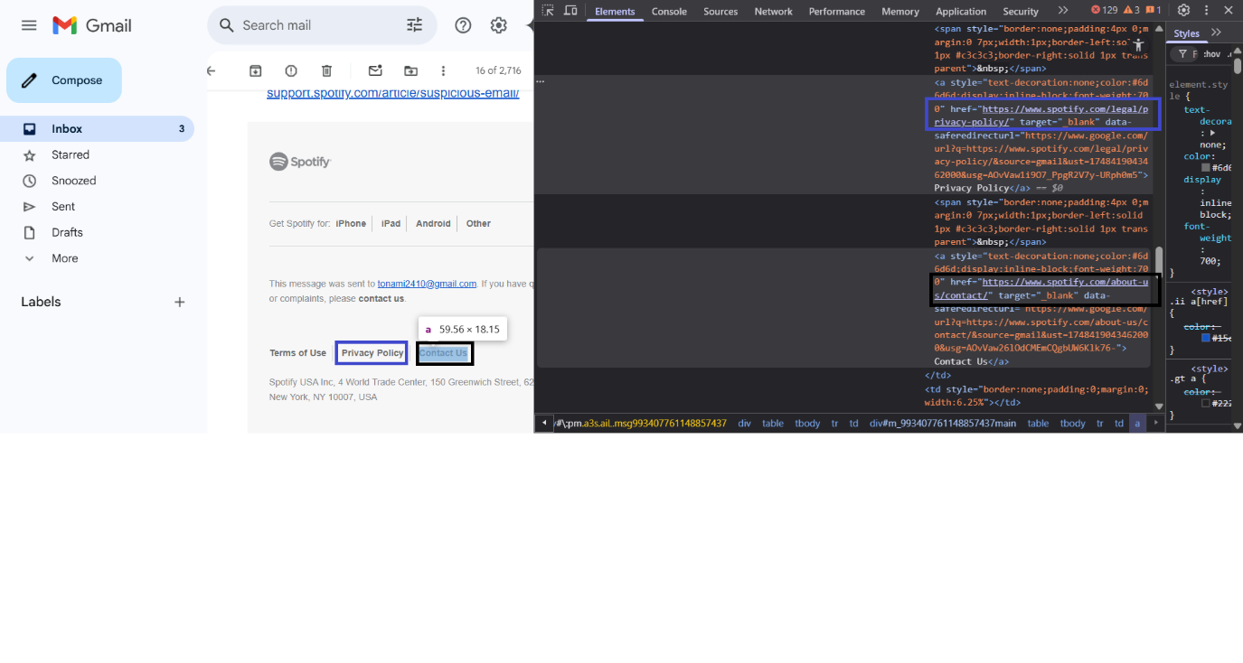

Phishing Page

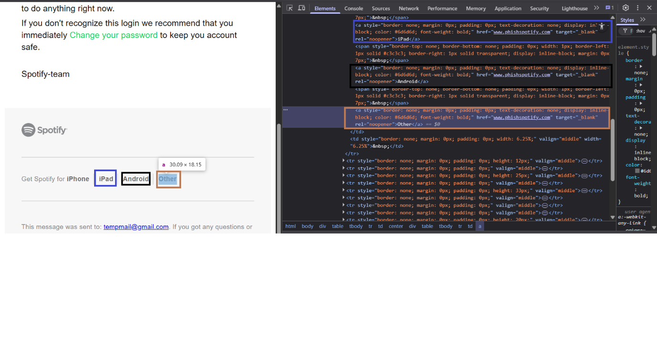

1. Additional checks

|  |  |  |
| --- | --- | --- |
| Feature | Legit Email | Phishing Email |
| Sender Domain | @spotify.com | @phishspotify.com |
| Regards | Make sure this email is from Spotify: support.spotify.com/article/suspicious-email/ | Spotify-team |
| Button | Contains Secure Account Button | Missing Secure Account Button |
| Timezone | America -> EDT | India -> CET instead of IST |